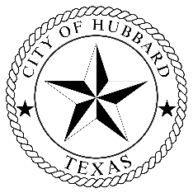 **City of Hubbard**

118 N Magnolia Ave Hubbard Texas 76648

____________________________________________________________________________

Mary Alderman, Mayor Jason Patrick, City Manager/Chief of Police

Kenneth Baldwin, Mayor Pro-Tem Diana Hall, City Secretary

Brandon Ivy, Council Member Carol Wallace, Court Clerk

Roger Lynch, Council Member Mary McCaghren, Utility Clerk

Wayne Taylor, Council Member

REVISED - 2025 TAXPAYER IMPACT STATEMENT

Median Value of Homestead is $130,511

Property Tax Bill for the Current Fiscal Year $1,063.15

Proposed rate is $0.8767/$100

Estimated Taxes using the proposed rate $1,144.19

No-new-revenue rate is $0.7004/$100

Estimated Taxes using the no-new-revenue rate $914.10